Tasks, Details, and Deadlines

* Research the compatibility between a Python API and Python, C#, and C++ scripts
  + Assumptions
    - The HSML API will be accessible through a port on the EC2
    - The plugins are packages of the respective consumers, producers, and JSON-to-HSML scripts

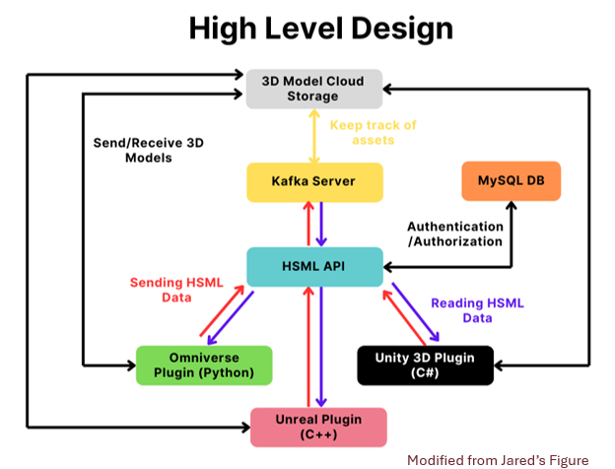

* + Understanding Apache Kafka
    - Apache Kafka: a server that follows a public-subscriber model with a data storage and processing layer
      * Public-subscriber model: publishers (Kafka Producers) send messages **categorized by topic**, to a central server (Kafka Server), which sends messages to subscribers (Kafka Consumers)
      * Kafka Producer: sends data to Kafka Server
      * Kafka Consumer: receives data from Kafka Server
  + Is it possible to connect to the HSML Python API hosted on an EC2 server from the metaverse scripts?
    - Yes. We can simply host the Kafka server on the EC2. The networking should be relatively the same. If we want it to be private, then we can create a Virtual Private Cloud (VPC) and host our Kafka/EC2 server within it. We can create a Virtual Private Network (VPN) and connect to the VPN on each of the metaverse hosts.
  + Are there any issues calling native language functions through the HSML API?
    - Calling native language functions through a Python API requires manual handling of information such as data types and memory management, which is not ideal. Instead, it would be better for the HSML API to only retrieve data from the standardized HSML JSON, rather than interacting directly with the metaverse plug-ins.
    - Question: We have producers for each plug-in, but I’m not quite sure why that would be better to interact with the HSML API, rather than the Kafka server directly. It seems more efficient to send Kafka messages to Kafka server, rather than facilitating it through the HSML API, which would require a standardized format, or manual interpretation of the native language to Python.
  + What does the programming implementation look like (for connecting metaverse plugins to HSML API from EC2)?
    - We don’t “connect” to the API—instead, we define routes for the HSML API where we can primarily receive and send data (as well as some other actions). From there, we can write some defined code to interact with the API.